**PRACTICAL :- 1**

**AIM :-** How to install and run **MASM 8086** .

Input –

Step 1 : Open your browser and type download **MASM 8086**.

Step 2: To run Masm 8086 we need to install DOSBOX.

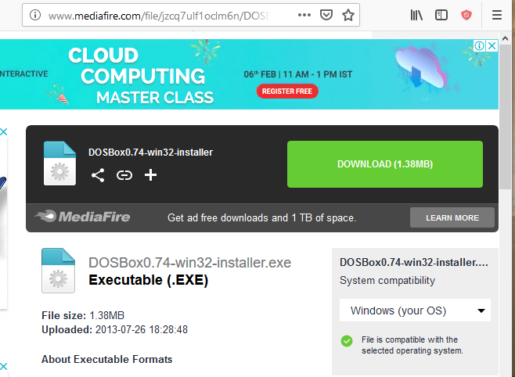

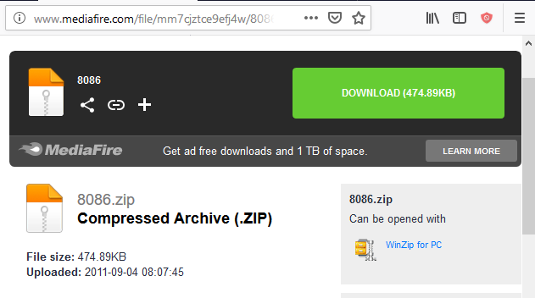

Step 3: Extract 8086 zip file into Cdirectory.

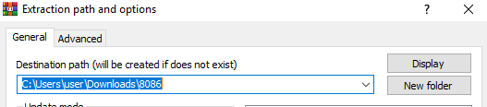

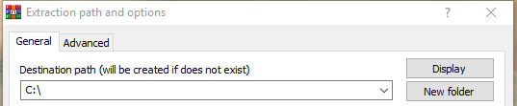

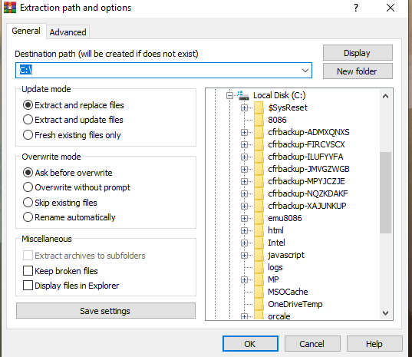

Step 4 : After that open DOSBOX.

Step 5: type command Mount C C:\8086 in dosbox.

Step 6: Then type command C:

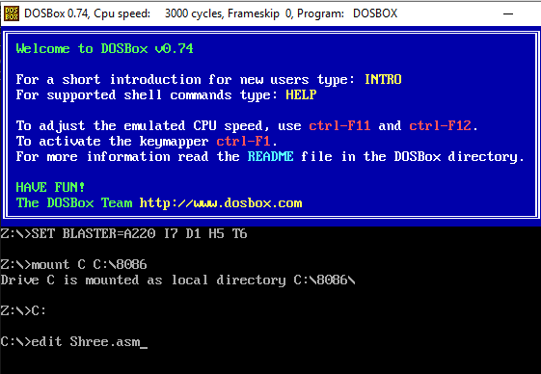

Step 7: Now enter the MASM software type: EDIT filename.asm

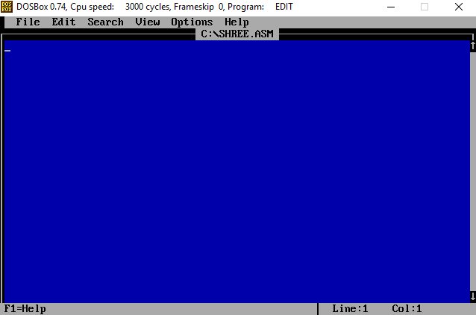

Step 8: 8086 assembler is open .